**TitLE of the presentation (times new roman 12, boldface, capitals, centRED, single space)**

**1 blank line, single-spaced, please leave 6 points before a new paragraph throughout the text**

**Author Name1*, Author Name2, Author Name2** (first name, middle initials and last name; please underline the name of the presenting author and indicate the corresponding author with * in the last name, e.g., Anne P.T. Silva*) (Times New Roman 11, boldface, centred, single-spaced)

1 Affiliation with complete address (Times New Roman 10, centred, single-spaced)

2 Affiliation with complete address, e-mail of corresponding author (Times N.R.10, centred, single-spaced)

**1 blank line, single-spaced**

**SUMMARY (TIMES NEW ROMAN 11, BOLDFACE, CAPITALS, LEFT JUSTIFIED)**

The authors are kindly requested to follow these guidelines for full paper submission. Manuscripts should be typed on A4 page format, left and right margins with 2.5 cm, top margin with 3 cm and bottom margin with 2 cm. The text should be in Times New Roman style, 11 points font, single-spaced and left- and right-justified, leaving 6 points before a new paragraph. Do not indent the beginning of the paragraph. Superscripts and subscripts should be at least 8 points in size, clearly visible and identifiable. Use italics for species names (e.g. *Pinus pinaster*) and Latin expressions. The full text of accepted papers must not exceed **eight (8)** A4 pages (including tables and figures).

**1 blank line, single-spaced**

**Keywords:** pleaseprovide maximum 5, in alphabetical order, separated by commas.

**1 blank line, single-spaced**

**INTRODUCTION** **(Main headings:** **times n.r. 11, bold, capitals, left justified)**

The text should preferably be divided into the following sections: SUMMARY, KEYWORDS, INTRODUCTION, EXPERIMENTAL, RESULTS AND DISCUSSION, CONCLUSIONS, ACKNOWLEDGEMENTS (optional) and REFERENCES. Please provide a summarywith no more than 200 words. The summary should present briefly the objective(s), the experimental procedure, the main results and conclusions of the work. English is the preferred language but full papers may also be submitted in Portuguese. In this case, a second summary written in English is mandatory.

To be published in the Conference Digital Support the **paper must be submitted online** as a Full Manuscript and have to be fulfilled the conditions described in the website. Moreover, the number of papers per registered author is limited to three, regardless whether they were chosen for poster or oral presentation. After submission, the corresponding author will receive a notification by e-mail. A comprehensive evaluation of the manuscript will be carried out by the Scientific Committee following previously defined and strict criteria. If necessary, modifications of the full manuscript will then be communicated to the corresponding author, together with the deadline for sending the final version in the Adobe PDF format. Authors are able to upload a new version of the full paper (maximum 2MB) at any time before this deadline, if they provide that information in the “Notes” field of the online Submission Form.

**1 blank line between sections, single-spaced**

**Experimental**

***Subtitle, if necessary (secondary headings: italics, bold)***

The techniques and materials used should be clearly explained or characterized (*e.g.*, indicate international standards such as ISO). Use as much as possible the International System of Units.

**1 blank line between sections, single-spaced**

**results and discussion**

All figures and tables must be referred to in the text and numbered with Arabic numerals as seen in Table 1. The text in the tables and the title of both tables and figures should be in Times New Roman 10, lower case, centred, bold. The titles should be placed above the table and under the figure and should be concise but self-explanatory. Do not duplicate the same information in tables and figures. For tables, units should be in parentheses in the headings. Use only horizontal lines: on the top and bottom and under column headings. Footnotes should be referred to in the table by a superscript. For numbers use a decimal point instead of a comma. Two short Tables or Figures could be placed side-by-side in two columns. This is also valid for one figure composed of parts a) and b) as shown in Fig. 2. Two figures with consecutive numbers may be arranged in the same way, with separate captions underneath each figure.

**1 blank line before table or figure, single-spaced**

**Table 1. Title of the table (Times New Roman 10, lower case, centred, bold).**

|  |  |  |  |
| --- | --- | --- | --- |
| Sample(a) | Length (m) | Pressure ×10-5 (Pa) | Velocity (m s-1) |
| Sample1 | 2.0 | 1.00 | 1.5 |
| Sample2 | 1.7 | 0.95 | 2.0 |
| Sample3 | 1.5 | 1.12 | 3.5 |

(a) - footnote

**1 blank line after table or figure, single-spaced**

Figures: please provide good quality figures preferably in grey scale or choose colours and/or patterns such that it would be understandable in a black and white print; in the text, elements of the figures should not be referred by their colour. Lettering on the figures should be in lower case using Sans Serif, Arial, Helvetica or Symbol fonts. Symbols should be defined in the legend or in the title. Axes should be labelled with units in brackets.

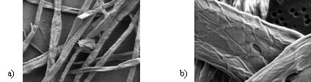**1 blank line before table or figure, single-spaced**

**Figure 1. Title of the figure: a) Times New Roman 10, lower case; b) centred, bold. The elements of a figure such as arrows, symbols or letters, should be grouped together as one graphical object.**

**1 blank line after table or figure, single-spaced**

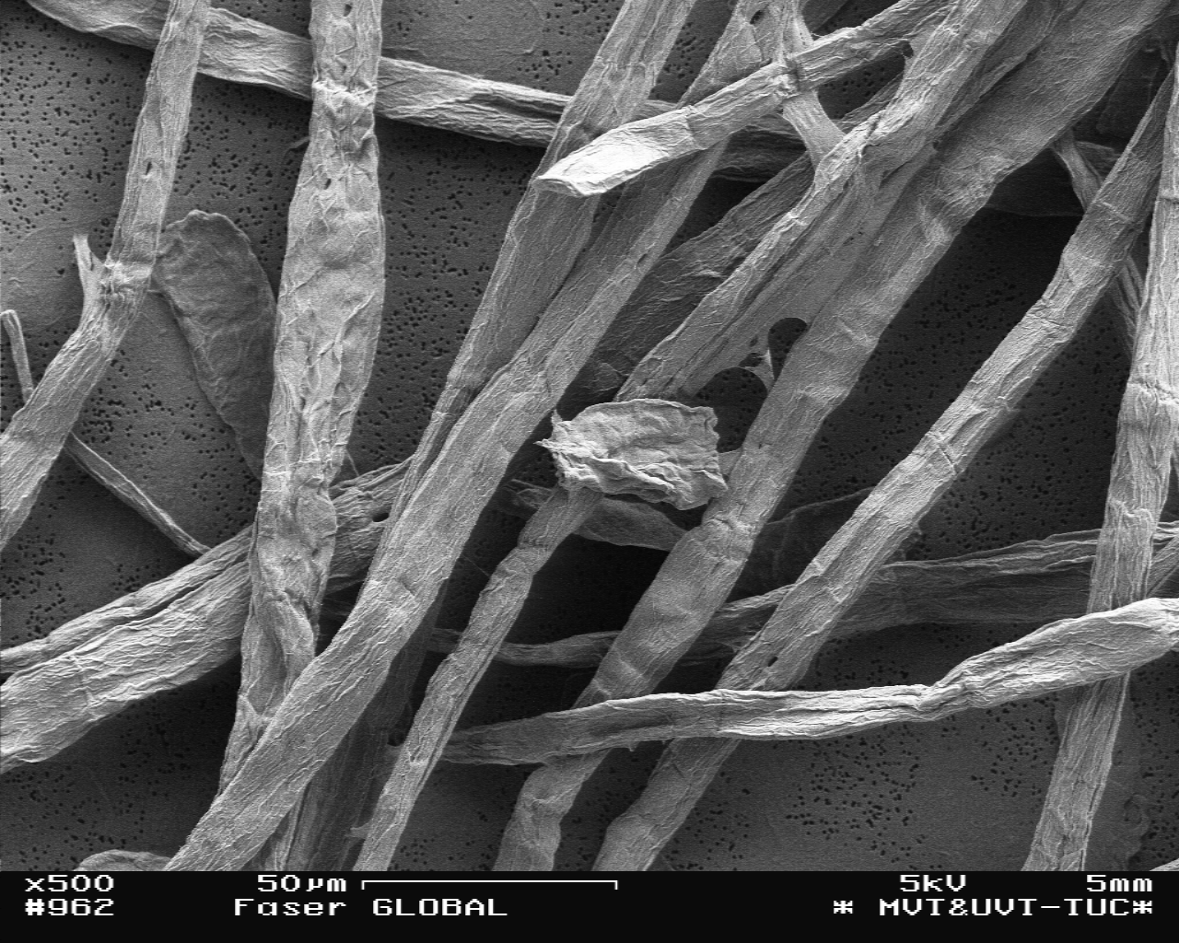

**Figure 2. The caption could also be placed beside the figure for low width illustrations or one isolated figure.**

**1 blank line after table or figure, single-spaced**

Figures must be carefully prepared and submitted ready for reproduction. The authors are responsible for the quality of Tables, Photos or Figures (300 dpi minimum). The paper in the final version should be printed before submission to see whether the quality of figures and graphics is good enough (e.g. JPG-compressed format is usually insufficient for publication). In the text, the figures or tables are referred to as “…in Fig. 1 (or Table 1)” but at the beginning of a sentence as “Figure 1 (or Table 1) shows …”.

All physical quantities and constants should be given in *italics* (not bold face) both in the text and equations. Units should be written in upright letters (not italics) with a space after the number. Equations may be numbered except for small in-line equations:

 (1)

Two short equations could be placed side-by-side in two columns and numbered. In the text, equations may be referred to as “... in Eq. (1)” and “Equation (1) shows ….” at the beginning of a sentence.

**1 blank line between sections, single-spaced**

**conclusions**

The conclusions have to be in accordance with the results presented and should be concise, clear and consistent.

**1 blank line between sections, single-spaced**

**Acknowledgements (Optional)** The services of …. are acknowledged.

**1 blank line between sections, single-spaced**

**references**

Include only the most relevant. Complete references are required. All references must be cited in the text by a number in square brackets, such as [1,2] or [1-3] and listed in this section in ascending order. Use font Times New Roman 10. Examples for Journals, Conference Proceedings and Books, respectively:

1. Authors’ initials and surnames (e.g., M. Silva), paper’s title, *J. Name* (journal’s name in italics and abbreviated), **volume** in bold face (number in brackets, if known): starting page−ending page (year of publication in brackets).

2. Authors’ initials and surnames (e.g., M. Silva), paper’s title, Proc. VI CIADICYP, place, volume, pp. starting page−ending page (year of publication in brackets). (Note: if only a CD with the proceedings is available please write (CD, total number of pages))

3. Authors’ initials and surnames (e.g., M. Silva), chapter’s title between commas, *in*: Book Authors (authors’ initials and surnames) or Editors (ed.), Book title, volume, Publisher, place (year of publication in brackets).